Problem 1: Context-free languages
Problem 1a
Context-free grammar $G_{1}=(V,Σ,R,S)$ where $V=\left\{S\right\}$ are the placeholders, $Σ=\{a, b, c\}$ is the output domain, the start symbol is $S$ where $S∈V$, and $R=\{S→aT, T→bTc | ε\}$ is a set of rules. This grammar $G_{1}$ generates the language $L_{1}=\{ab^{n}c^{n} | n≥0\}$, i.e. $L\left(G_{1}\right)=L_{1}$.
Problem 1b
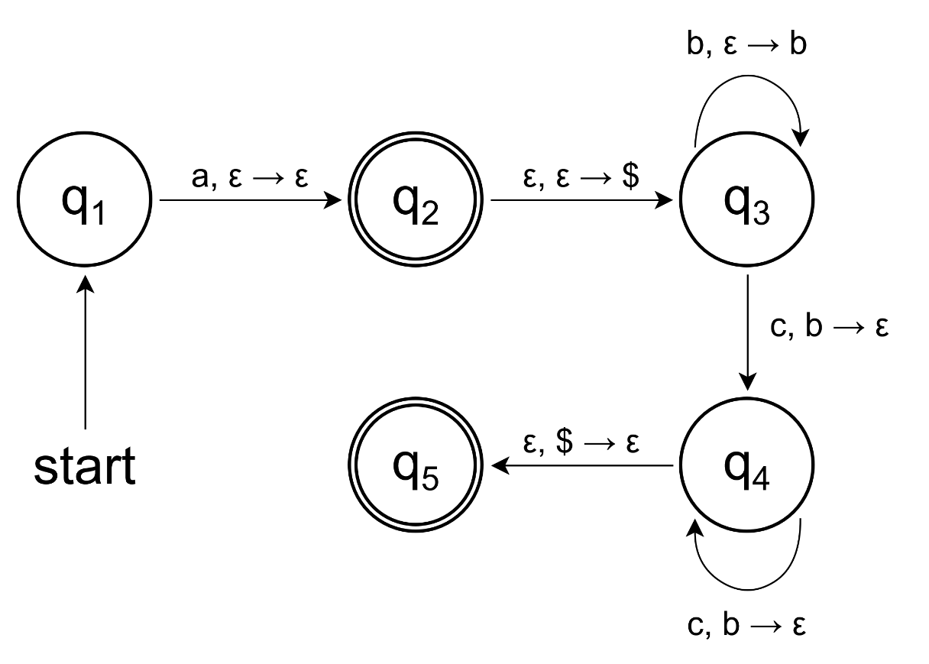
Problem 1c
The simplest way to show that $L_{2}=\{a^{i}b^{j}c^{k} | i,j,k≥0, and i+j=k\}$ is context-free is by either creating a PDA that recognizes this language, or by creating a CFG that generates this language. I will go with the CFG route which I define as $G_{2}=(V,Σ,R,S)$ where $V=\{S,T\}$,
$Σ=\{a,b,c\}$, $R=\{S→aSc | T | ε, T→bTc | ε\}$. As you can see $G_{2}$ creates the language $L_{2}$.
Problem 2: Pumping lemmas
Problem 2a
First, we assume that the language is regular. Thus, there exists a DFA with $p$ states (also called pumping length) that accepts all the inputs of that language. According to the pumping lemma all these inputs can be divided into 3 parts, $w=xyz$, and there are 3 conditions that always hold. Now, all we have to do is come up with an input that is accepted by the definition of $L_{2}$, but breaks one of the pumping lemma’s conditions, i.e. a counter example. I chose $w=a^{p}c^{p}$ which according to the 3rd condition “$\left|xy\right|≤p$” means that $xy$ in $w$ consists of only and all $a$s. In addition to that, due to the 2nd condition “$\left|y\right|>0$” $y$ must consists of only $a$s, i.e. $y≠ε$, but there is no such rule for $x$. Due to this, the 1st condition “$xy^{i}z∈L_{2} for all i≥0$” breaks when $i≥2$ because it is then that there isn’t any valid decomposition of $w=xyz$ such that the amount of $c$s is the sum of the amount of $a$s and $b$s (as required by the definition of $L_{2}=\{a^{i}b^{j}c^{k} | i,j,k≥0, and i+j=k\}$) since $a$s are increasing in count whilst that of $c$s isn’t.
Problem 2b
To prove that the language $L_{3}=\left\{a^{i}b^{j}c^{k} | i,j,k≥0 and i×j=k\right\}$ is not context-free, for the sake of contradiction, we assume that it is context-free. This means that there exists a PDA with $p$ transition states that accepts the language. Here we also use the pumping lemma (which is different to that of the regular languages) according to which we can split the input into 5 parts, $w=uvxyz$. This time I chose input $w=a^{p}b^{p}c^{p^{2}}$ where due to the 3rd condition “$\left|vxy\right|≤p$” and 2nd condition “$|vy|>0$” we get 5 ways to split it up, i.e. 5 cases:
- $u$ is an $ε$, $vxy$ contains only and all $a$s where, in terms of the count of $a$s, $x$ is at least an $ε$ and at least either $v$ or $y$ contains an $a$, and $z$ contains only and all of both $b$s and $c$s.
- $u$ contains only and all $a$s, $vxy$ contains only and all $b$s where, in terms of the count of $b$s, $x$ is at least an $ε$ and at least either $v$ or $y$ contains a $b$, and $z$ contains only and all $c$s.
- $u$ contains only and all of both $a$s and $b$s, $vxy$ contains only but not all $c$s where, in terms of the count of $c$s, $x$ is at least an $ε$ and at least either $v$ or $y$ contains a $c$, whereas $z$ contains the rest of $c$s.
- $u$ contains only but not all $a$s, $vxy$ contains both $a$s and $b$s, but not all of either, where in terms of the count of both $a$s and $b$s, $x$ is at least an $ε$ and at least either $v$ or $y$ contains an $a$ or a $b$, and $z$ contains the rest of $b$s and all $c$s.
- $vxy$ contains both $b$s and $c$s, but not all of either, where in terms of the count of both $b$s and $c$s, $x$ is at least an $ε$ and at least either $v$ or $y$ contains a $b$ or a $c$, $u$ contains all of $a$s and the rest of $b$s, and $z$ contains only and the rest of $c$s.
In all the cases the 1st condition “$uv^{i}xy^{i}z∈L_{3} for all i≥0$” breaks when $i≥2$ because it is then that there isn’t any valid decomposition of $w=uvxyz$ such that amount of $c$s is the product of $a$s and $b$s (as required by the definition of $L_{3}$). In cases 1, 2, and 4 the amount of $c$s remains constant whilst the amount of a$s$ and/or $b$s doesn’t. In case 3 the amount of both $a$s and $b$s remains constant whilst the amount of $c$s doesn’t. Lastly, in case 5 both the amount of $b$s and $c$s grow at a constant rate whilst the amount of $a$s doesn’t which is wrong. That is because the amount of $c$s must grow at an increasing rate in accordance with the growth of the amount of $b$s, which it does not. More formally, pumping increases both the number of $b$s and $c$s. Now, let $t$ and $s$ be the amount of $a$s and $b$s added by the increase. Then, the string can be described as having $p$ amount of $a$s, $p+t$ amount of $b$s, and $p^{2}+s$ amount of $c$s. Due to the product requirement, the amount of $a$s and $b$s with respect to $c$s must be and can be described as $p×\left(p+t\right)=p^{2}+p×t=p^{2}+s$. This implies that $p×t=s$, but since $pt≥p≥s$ this does not hold in the general case, i.e. only in a restricted case when $pt=s$.
Problem 3: Turing machines
Problem 3a
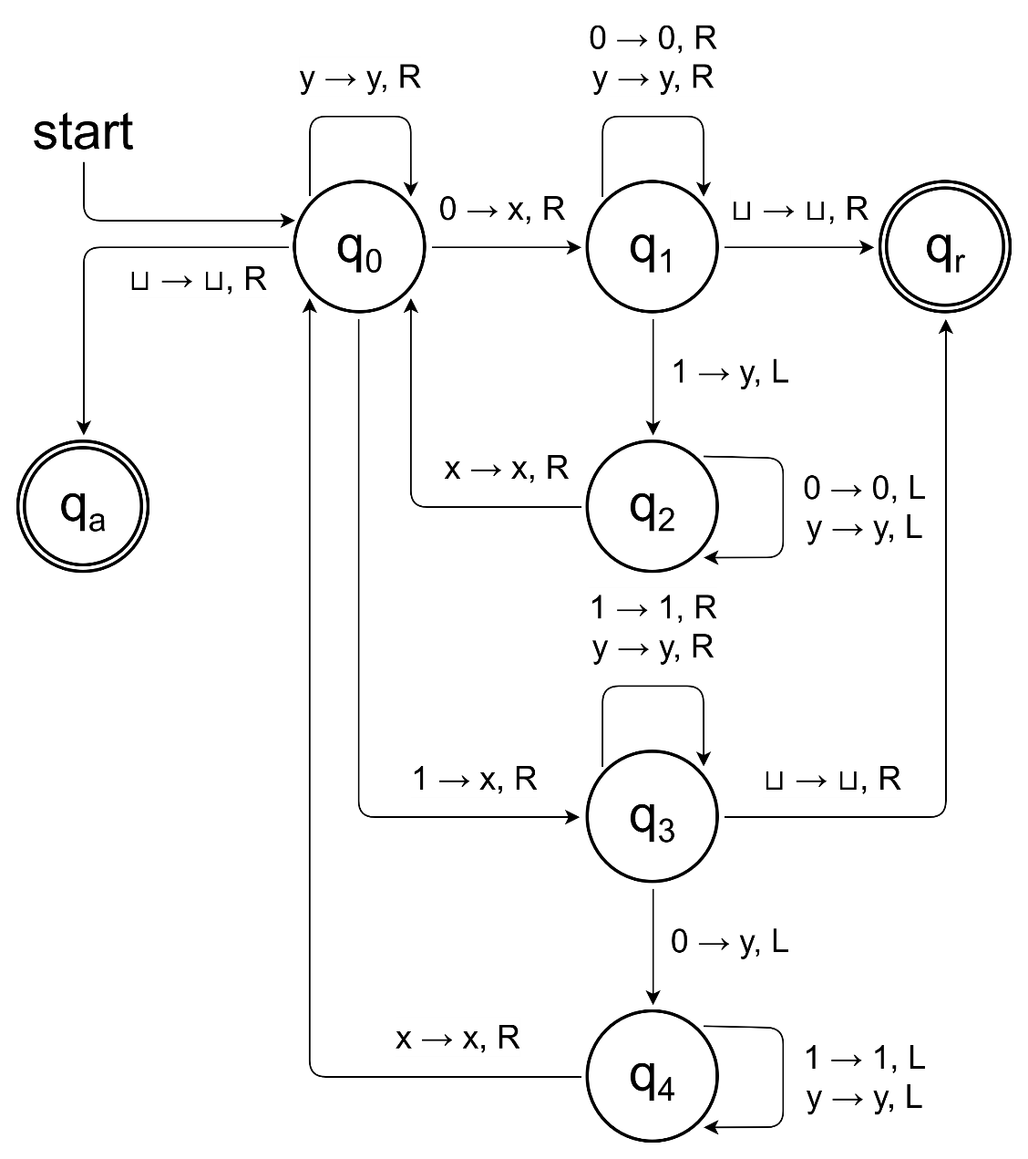
Problem 3b
First, I set up an environment where the machine can also sweep right to left where a blank cell acts as an indicator to stop sweeping, switch sweeping side, or both. Simultaneously, we accept the base case where an input is empty.
- Read, then write to the first cell a blank.
- If in 1st step the cell contained a blank, accept.
- If in 1st step the cell contained a 0, sweep right and replace first blank cell with a 0.
- If in 1st step the cell contained a 1, sweep right and replace first blank cell with a 1.
- Sweep left until the first blank cell is reached.
Next, for each 1 that is found and crossed off we find and cross off two 0s. If at any point during this process the amount of either is found to be insufficient, we reject the input.
- Sweep right crossing off the first 1 that is found.
- If in 6th step we reach an empty cell before a 1 was found, reject.
- Sweep left until the first blank cell is reached.
- Sweep right crossing off two 0s.
- If in 9th step we reach a blank first, reject.
Lastly, we verify that everything is crossed off, if it is we accept, if it isn’t we go to 5th step which sets up the next cross off (steps 6 to 10) and this verification (steps 11 – 13).
- Sweep left until a 0 or a 1 is found.
- If in 11th step we reach a blank first, accept.
- Go to 5th step.

